

2 Minute Form
Trip Name: Sandspit to Matakana
Check-in Name and Phone:
Date: Branch:
Leaders
Cell Phone Number
VHF Call Sign &/or Vessel Name
Vehicle make, model, registration, colour
General Plan
Note: If plan changes, you must notify your Check-in person.
Latest Time Off the Water |  |  |  |  | TMP used²⁰
Tide/ Forecast Lake Level | Low |  |  | High | Other
Communications Carried²¹ | VHF, Cell phone
Communications | We will be communicating as a group on VHF Channel
Equipment Carried
Trip Report
(Use other side if more space required)

Activity | Sandspit to Matakana | Centre | Auckland/North Shore/Manukau | Location |  |  |  | Sandspit |  | Difficulty¹ |  |  |  | Beginners
Activity Description | Sandspit is very tidal. If the tide is in you can launch from Sandspit Holiday Park beach front, otherwise there is an all-tide boat ramp at Sandspit Wharf. |  |  |  | Leader qualification req.² |  |  | Trip Leader
Get in Location | Sandspit Wharf |  |  |  | Chart/ Map no.⁴ |  |  | NZ 5227 |  | Distance |  |  |  | 12-30km
Get out Location | Sandspit Wharf |  |  |  | Coastguard Channel |  |  | 80 & 82 |  | Nowcasting |  |  |  | 21
Emergency get out ⁵ | Side of the estuary in some places. |  |  |  | Emergency / Coastguard Station |  |  | Auckland |  | Phone |  | *500 / 09 303 4303
Emergency get out ⁵ |  |  |  |  | Drinking Water⁶ |  | Sandspit Camp |  | Toilets⁷ |  |  |  | Matakana or Sandspit Wharf
Emergency Response | Refer Emergency Response Booklet |  |  |  |  |  |  |  | Parking⁸ |  |  |  | Matakana or Sandspit Wharf
Specific Equipment Required⁹ | Trolley to transport the kayak to/from the wharf if you don’t want to load it onto vehicles or carry it. |  |  |  | Working Communications equipment in this area¹⁰ |  | Cell phone  Sat phone |  |  |  |  |  |  |  | PLB  VHF
Other resources  and notes¹¹ |  |  |  |  | Weather Parameters¹² | Beginner: no significant surf or swell, wind under 15 knots.  Intermediate: surf or ocean swells less than 1.5 metres or wind under 25 knots.  Advanced: any condition that’s suitable for the trip’s aims.
Previous incidents¹³

Safety Management¹⁴
Hazard |  | Significant?  - E/I/M |  | Management Strategy¹⁵ |  |  |  | Hazard | Significant?  - E/I/M | Management Strategy¹⁵
Cold Water |  | Yes - M |  | Carry spare dry clothes and shelter |  |  |  | Deep Water | Yes - E | Correctly fit PFDs
Medical Conditions |  | Yes - M |  | - Leader has first aid qualification  - Ask customers about medical conditions |  |  |  | Bad Weather | Yes - M | Understand weather forecasts.  Have back up plans or pull out if necessary
Capsizing |  | Yes - M |  | - Correctly fit PFDs  - Skills at performing rescues. |  |  |  | Heat / Sun | Yes - M | - Protective Clothing (worn), Sunglasses, Hat  - Sun Screen  - Plenty of drinks
Panic |  | Yes - M |  | Ensure conditions match level  of skills |  |  |  | Obstacles | Yes - M | Awareness of reefs, navigational hazards, nets
 |  |  |  |  |  |  |  | Other Vessels | Yes - M | - Understand the “rules of the sea”  - “Be seen” – Have two of the following; flag, brightly coloured kayak, brightly coloured Pfd or hat. At night: an all- round white light & a powerful torch.
Written up by: | Larraine Williams |  | Approved By: |  | Russell Williams | Signed: | RW |  | Date: | 26 June 2014 | Review in: | 12 months from date of approval
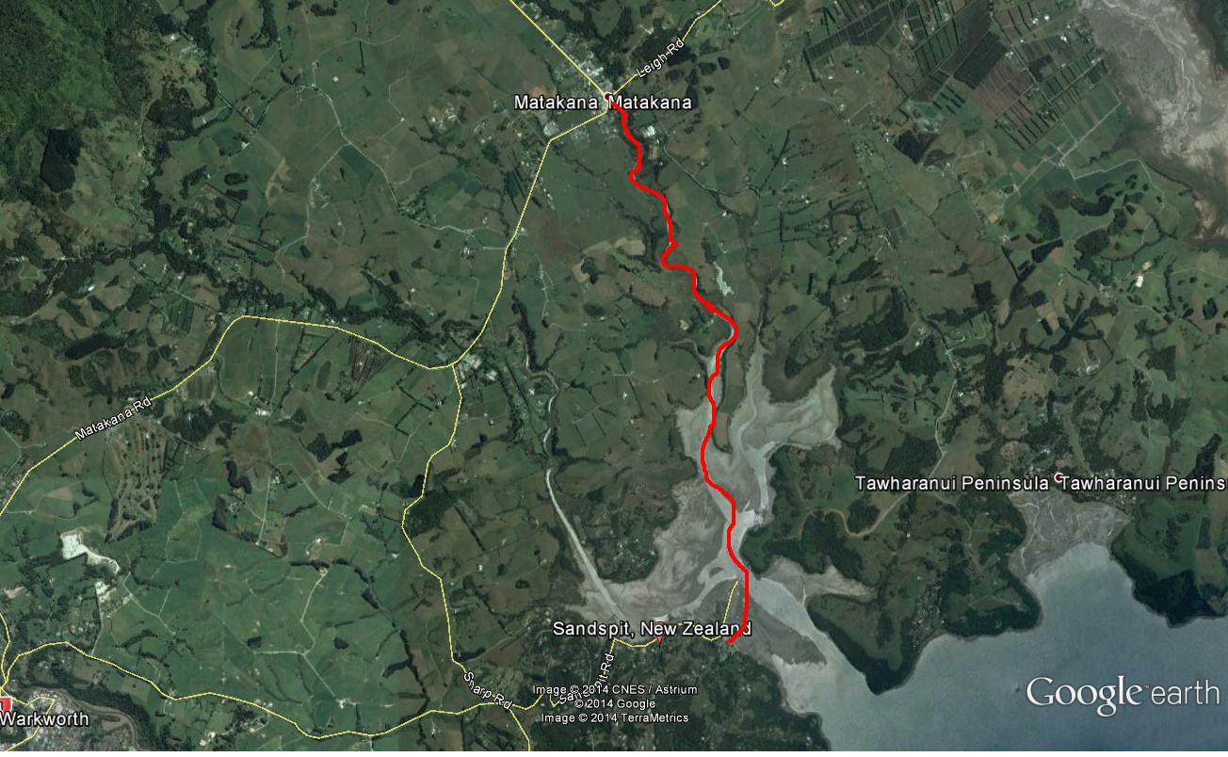

Additional Information Sheet (Optional)
Introduction |  | The campsite location is right on the water overlooking the Matakana River and next to the wharf where the ferry leaves for Kawau Island.  There are good facilities at the camp ranging from self contained cabins to tent sites. There is a good communal kitchen and BBQ area.  There are lots of good paddling options in the area – coastal, harbour/river and islands. Sandspit is very tidal but very handy to good launching spots.
Description |  | From Sandspit we can launch from the beach if the tide is in and return to the boat ramp at the wharf.  If the weather is bad we can go to Matakana Markets, Brick Bay Sculpture Trail, Wine tasting, Walks etc.
Local Attractions |  | Transport/ Local Operators
Matakana Markets | Matakana Village |  | Saturday morning until 2pm
Brick Bay Sculpture Trail | Arabella Lane, Snells Beach.  09 4254690  www.brickbaysculpture.co.nz |  | Vineyard, cafe , sculpture trail (Highly recommended)
Omaha Bay Vineyard | 189 Takatu Road, Matakana.  094230022 |  | Spectacular views. Open 11am to 4pm Friday to Sunday Winter  Open11am to 5pm Wednesday to Sunday Summer
Local Eateries
The Matakana Pub | 11 Matakana Valley Rd  09 4227518 |  | The Matakana was built in 1903 by the postmaster from a single Kauri tree and is in the heart of the village. Good meals, fast service.
Cafe Sandspit | 1440 Sandspit Road  09 4259475 |  | Cafe is on Sandspit Wharf. Open 9am – 3.30pm
Accommodation/ Campsite Locations |  |  | Facilities
Name | Sandspit Holiday Park |  | Cabins | Self contained cabins have kitchen, bathroom and linen.  Kitchen cabins have kitchen but no bathroom. Bring own linen. | Fuel
Phone | 09 4258610 |  | Showers | Yes | Power | Yes
E-mail | sandspit@xtra.co.nz |  | Toilets | Yes | Water Access | Situated on water but tide goes out a long way
Website | www.sandspitholidaypark.co.nz |  | Laundry | yes | Pool | no
Physical Address | 1334 Sandspit Road, RD2, Warkworth |  | Water | yes | Fires Allowed | no
Other |  |  | Supplies
Other information | Camp sites available. Cabins sleep from 2 to 10 people.  Communal kitchen, laundry, ladies and men’s amenities blocks, BBQ area, games room/library, TV room.

Activity Equipment Check list
Equipment List
- Helmet (rivers & surf) Group Gear
❑ Beanie / hat  Split paddles
❑ Thermals  Repair kit
❑ Paddle Jacket  Fire lighting
❑ PFD  Cooker/thermos
❑ Spray deck  Spare thermals
❑ Booties  Tow system
❑ Water & food  1st Aid Kit
❑ Kayak & paddle  Flares
Group - Oceans & Lakes  Compass
❑ Pumps & Paddle Floats  Charts / Maps
Group - River  GPS (optional)
❑ Throw ropes  Knife (cut rope)
❑ Pin kit & saw  Emergency Shelter

In case of emergency: Dial 111, Mayday :VHF Channel 16

Kayaking Check list

❑ Trip plan
❑ Latest weather forecast
❑ Conditions match skills?
❑ Hyperthermia (hot) &
Hypothermia (cold)
❑ On & off water safety
❑ Environmental concerns
❑ Emergency Procedures include emergency get out.
❑ Working communication devices
e.g. VHF radio, mobile phones, PLB
❑ Specific safety issues for this trip
❑ Participant list
❑ Any medical conditions
❑ All participants keen to proceed?

❑ Trip Plan/ 2-minute form lodged with Ops. Manager

Appropriate wind conditions to run trips:
Novice - no significant surf or swell, wind under 15knots
Intermediate- surf or ocean swells less than 1.5 metre or wind under 25 knots.
Advanced- any condition that is suitable to the trips aims

At conclusion of trip:
Contact check in person
Group Debrief.

Check in Person Ph:
__________________ Mobile
__________________ Work
__________________ Home

Activity Document Cover Sheet

Activity:
Date of Activity:

Activity reports. Is all relevant information present:
– Approved Trip Management Plan (TMP)/ 2 minute form
– Club Trip Participant Sheet
– Weather forecast
– Activity Check List
– Trip report (May be on the 2 minute form)
– Accident / incident reports
Leaders Signature:
Date:

